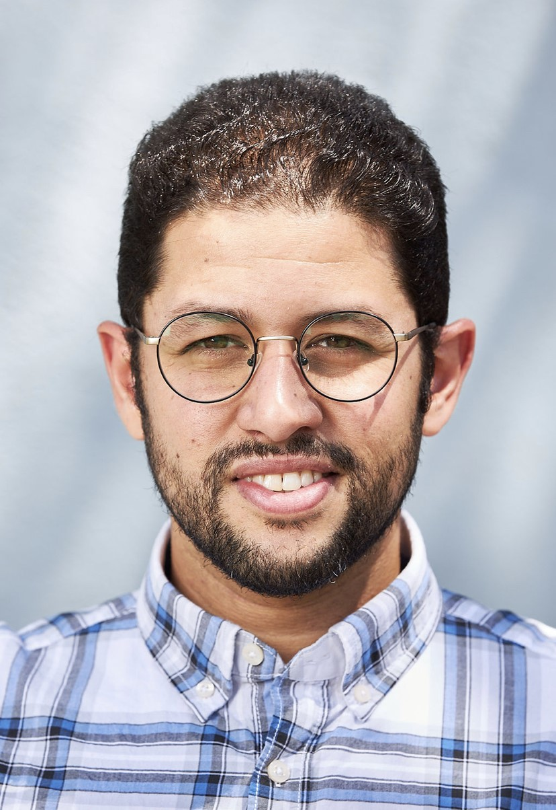
Kareem El Damanhoury

(Non-Union)

Height: 5’ 7” (172 cm)
Weight: 170 lbs (77kg)
Eye Color: Hazel
Hair Color: Brown

____________________________________________________________________________________

THEATER

In a Forest Dark and Deep Bobby Lost Flamingo Theatre ‘14
The Murderous Mansion of Mr. Uno Mr. Uno Lost Flamingo Theatre ‘13
Ghost to Every Citizen (Arabic) Rady, Ghost Cairo University, 10

____________________________________________________________________________________

FILM/TV

Far From Home Lead Ohio University ‘15
What’s After Z (Arabic) Lead First Step, ‘14
Oh, Shoot Supporting Ohio University ‘14
The University (Arabic) Supporting MBC, ‘10
Safeya’s Case (Arabic) Supporting ٍScreen 2000, ‘10

____________________________________________________________________________________

EDUCATION & TRAINING

Ohio University: MA in Media & Journalism
Acting & Improv Workshop: Actor Studio, Cairo, Egypt
____________________________________________________________________________________

SPECIAL SKILLS
Swimming, Fencing, Air Pistol Shooting, Horse Riding, Arabic Language, Drone Pilot License, Driving License

